COSC 4333: Distributed Systems
Assignment 1
Due: 10:00am, Sept. 6, 2024 (Friday)

Name: ____Andrew Kalathra____

LUID: _____L20498001______

Date: ______09/06/24________

(10 points)
- What is the role of middleware in a distributed system?
  - The middleware is also known as the distributed system layer.
  - The middleware extends over multiple machines and offers each application (on the separate machines) the same interface.
  - This means that different operating systems can have the same experience.
  - This is done through specific properties, such as transparency in all of these characteristics: access, location, migration, relocation, replication, concurrency, and failure.

(15 points)
- What is meant by a scalable system?
  - Scalable systems are focused on centralization in services, data, and algorithms.
  - Scalable systems are meant by the scale that an application can be used at, whether it be on multiple devices or across the world. In essence, the system is more capable of handling more users, data, and changes to meet demand.
  - Common scaling techniques include hiding communication latency, distribution, and replication.

(15 points)
- Please follow the “How to Connect to Linux Servers in CS Department” document to log into the Linux server and use dig command to resolve host names to IP addresses:
This link shows more details about dig: https://linux.die.net/man/1/dig
Please try the following commands:
dig www.lamar.edu
dig www.cs.lamar.edu
dig. www.uh.edu
Based on the output, report the IP address of the above hosts. What name server is used during the IP address lookup process?
- For www.lamar.edu, the IP address was: 140.158.64.248; the name server was 140.158.50.20 at port 53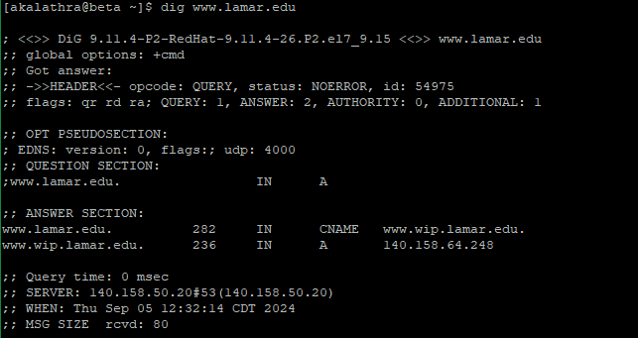

- For www.cs.lamar.edu, the IP address was: 140.158.128.16; the name server was 140.158.50.20 at port 53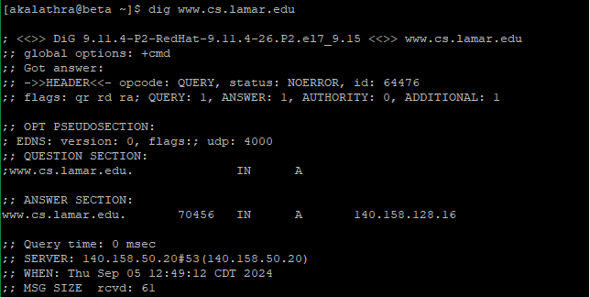

- For www.uh.edu, the IP address was: 129.7.97.54; the name server was 140.158.50.20 at port 53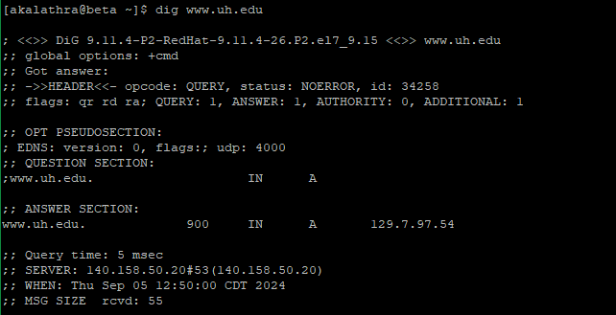

(60 points)
- Wireless sensor network (WSN) is one example of distributed pervasive systems. Please read the paper “Wireless sensor networks: a survey” by I.F. Akyildiz, W. Su*, Y. Sankarasubramaniam, E. Cayirci, Computer Networks, 38 (2002) 393-422.
You do not need to understand the protocol details and may ignore the complex mathematical equations.
After reading, please write a brief survey (about 400 words) to summarize WSN and its major characteristics from a distributed system perspective.

WSN and its Major Characteristics from a Distributed System Perspective:
Sensor networks are a group of sensors used together for specific applications. Example included would be in the medical profession, to help be more convenient for patients and help physicians get a better overview, or in the environment, to assess chemicals and pollution. The power of these systems lies not just in their quantity, but also in their ability to process their data independently before sending that processed data.
Ad hoc networks can be used for sensor networks, but they are characterized differently. Ad hoc quite literally means “as necessary”, so the scale of sensors used in ad hoc vs traditional is quite less, much less dense, is usually fixed, and have fixed ID’s.
Multihop communication allows multiple sources of data (captured and processed by these sensors) to be sent through each other. This means there is no centralized node, but rather, the nodes can use each other to send their data. This is more efficient for these sensors since there are a high density of them, and this would conserve energy, which is much needed.
The communication architecture is most directly related to distributed systems due to the protocol used in data collection and routing. The protocol stack given is similar to other protocols, with layers such as the application layer, transport layer, network layer, data link layer, and the physical layer, but is also different as it consists of different planes, mainly the power management plane, mobility management plane, and the task management plane.
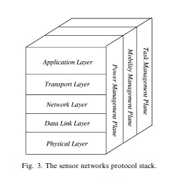
As seen in the image, the basic layers must also take into account the 3 different planes. The application layer is the top layer, which accomplishes the main objective the sensor was made for (like sensors for temperature would capture the temperature using the sensor). There were three proposed protocols tested, all three being open research issues to link the application layer with the rest. The main problem with all of these lied in overall minimal service in each individually. The transport layer’s purpose is to help gain access to the system via the internet or other sources. There has been no progress in creating a specific protocol for this layer (and for its specific needs) as the usual TCP protocol will not suffice. The network layer is meant to help in the communication of these nodes, such as described in multihop communication. A variety of factors affect this layer that are specific to the needs of the sensors. Different schemas have been developed for this layer, prioritizing effective data transferal and minimum energy consumption, the best being SPIN (a reactive protocol). This protocol sends the description of the sensor instead of all the data. This protocol utilizes different messages, assignments, and algorithms. The data-link layer is focused on point-to-point or point-to-multipoint connections in the network. Utilizing the traditional MAC schemes have been unsuccessful due to the sensor needs. Other systems have been used in conjunction with MAC schemes, but developments need to be made. The physical layer is the lowest layer, “responsible for [things like] frequency selection, carrier frequency generation, signal detection, modulation and data encryption.” Communication in such systems are wireless, which makes it more expensive and adds an additional requirement of having to use a diversity of techniques and systems. A main development needed at this layer is just a redesign of the hardware, in that low-cost, low-power, yet very powerful sensors can be made.

How to Turn In:
Softcopy: Please use BlackBoard to turn in your homework solutions.

